Problem Statement 1: Store Performance and Workforce Productivity – Framing Note
Business Analyst, Global Retail Analytics | For: Head of Store Operations | Tool: Excel (Power Query, Power Pivot)
Evidence base: 35 stores in 7 countries, 1,746 employees and 3,340,935 transaction lines, 1 Jan 2023 – 18 Mar 2025. All amounts in USD (1 EUR = 1.08, 1 GBP = 1.27, 1 CNY = 0.14); returns are netted out of sales. Headcount comes from the employees table, because the stated Number of Employees disagrees with it for 5 stores. Figures are a first look at the data; Part B tests them.
Situation. Zara's 35 stores made $57.5M in net sales in 2023 and $58.2M in 2024. Complication. Sales per employee range from $121,111 (Fifth Avenue) to $40,137 (Zeil), a 3× gap. Spain, the home market, grew 2.3% in 2024 while the US grew 14.9% and China fell 12.4%. Footfall is uneven: Saturday carries 22–29% of a week's sales, and the German stores close on Sundays. Question. Which stores underperform and why, and are staff in the right places at the right times?
Problem statement. The Head of Store Operations is facing a 3× gap in sales per employee between stores while trying to decide where to put staff hours, which results in weak stores being cut back and falling further behind. How might we help store managers put their people on the busiest days, so that weaker stores sell more per employee without adding labour cost?

1. Issue tree
"Why do some stores sell far less than others?" splits into five branches that do not overlap (MECE). Each ends in something Excel can measure.
Branch | Sub-question | Measure in Part B | First look
Market and location | Does the country or city explain the gap? | Net sales by country; each store vs its country average | US +14.9%, China −12.4% (2024)
Number of transactions | Do weak stores serve fewer customers per employee? | Invoices per employee | 1,857 at Fifth Avenue vs 495 at Zeil
Basket size | Do customers in weak stores spend less per visit? | Average basket value; units per invoice | $65 at Fifth Avenue vs $81 at Zeil
Staffing | Does headcount follow sales? Where are staff short or surplus? | Sales per employee; staff gap vs company average | Correlation 0.89; gaps from +19 to −34 staff
Product mix | Do weak stores sell a different mix, or lose more to returns? | Category mix; return rate by store | Germany returns 15.5% of sales vs 10.9% overall

2. Systems thinking: the feedback loop and the iceberg
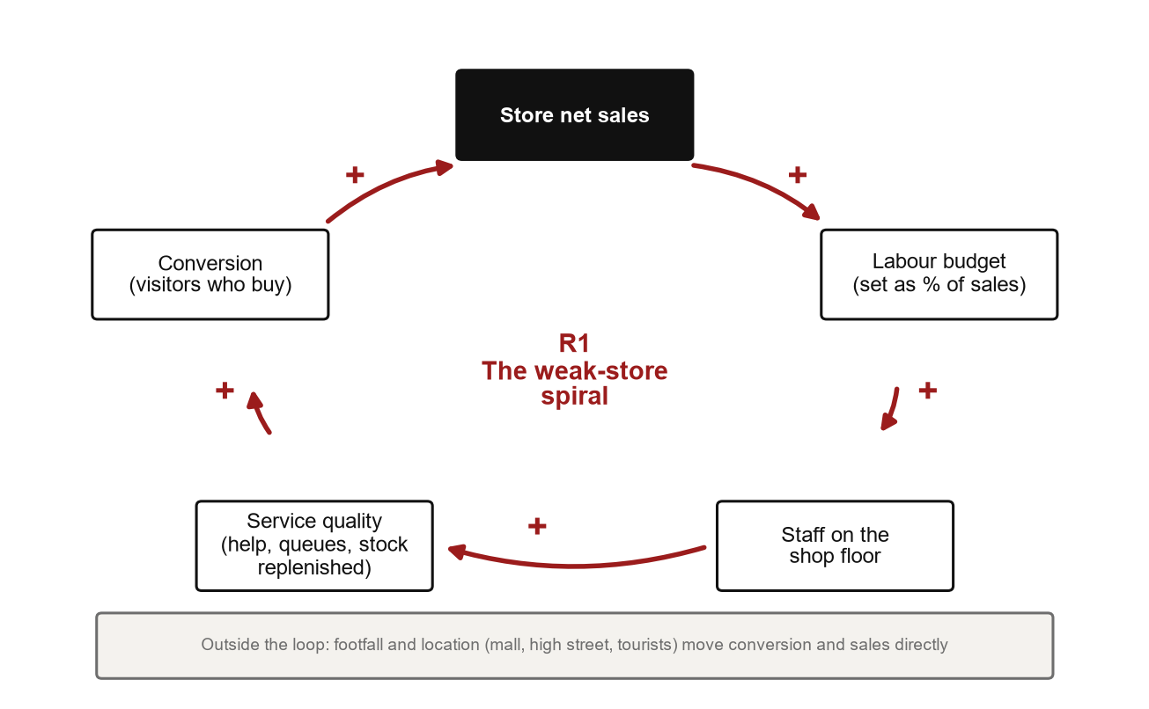
Causal loop. + = the two move the same way; − = opposite ways; R = reinforcing loop.
- Reinforcing loop (R), a vicious cycle. Lower sales → smaller labour budget → fewer staff on the floor → slower service and longer queues → fewer browsers become buyers → lower sales. Left alone, a weak store keeps sinking.
- Leverage point. The roster, not the headcount. Putting staff on Friday and Saturday, when 36–48% of a week's sales happen, can lift conversion without adding cost. Location and footfall sit outside the loop.
Iceberg level | In this problem
Event (what we see) | Zeil sells $40K per employee, a third of Fifth Avenue
Pattern (to confirm) | The same stores stay at the bottom every month; the gap is widest on Fridays and Saturdays
Structure | Labour budgets follow last period's sales; rosters spread hours evenly across the week
Mental model | "A quiet store needs fewer staff", which may cut staff exactly when customers come in

3. Stakeholder map (power–interest grid)
 | Lower interest in store productivity | Higher interest in store productivity
Higher power over staffing | Keep satisfied: HR. Needs evidence before any hiring or roster change. | Manage closely: regional and store managers. Need a fair ranking and guidance they can act on in their own store.
Lower power over staffing | Monitor: customers. Feel the result as queues and service. | Keep informed: sales associates. Need targets that do not punish a quiet shift.

4. User research
Method: semi-structured interviews with store managers (generative research). Questions ask about past weeks, not hypothetical ones, and avoid leading wording. No interviews have been held yet, so both personas are drafts to validate.
 | Store manager (draft) | Frequent shopper (draft)
Who | Runs one store with 24–106 staff; reports to a regional manager | Shops in store every few weeks, mostly for new arrivals
Goal | Hit the sales target inside the labour budget | Find the right size quickly and leave
Pain points | Weekly numbers arrive late and mix sales with returns | Queues and nobody free in the fitting rooms on Saturdays
Job to be done | When the week looks off, I want to see which days I was short, so I can fix next week's roster | When I have little time, I want help fast, so I can buy and go

# | Interview question (store managers) | What it tests
1 | Walk me through last Saturday. When did it get busy, and how many people were on the floor? | Peak-day staffing
2 | How did you decide who worked which shift last week? What did you look at? | How rosters are made
3 | Think of your best week this year. What was different from a bad week? | Drivers the data cannot see
4 | The last time you were short-staffed, what did customers stop getting first? | The service → conversion link
5 | Which numbers do you check each week, and which do you not trust? | Scorecard requirements
6 | If you could change one rule about staffing or targets, what would it be? | Constraints and quick wins

5. Metric tree
North Star: net sales per employee per month (USD). It joins what a store earns with what it spends on people. It is a lagging indicator, so the tree breaks it into leading inputs a store can move this week.
Level | Metric | Calculation | Type | 2024 baseline
North Star | Net sales per employee per month | Net sales ÷ employees ÷ months | Lagging | $2,779
Input | Invoices per employee | Purchase invoices ÷ employees | Leading | 33 a month
Input | Average basket value | Net sales ÷ purchase invoices | Leading | $84.57
Input | Units per invoice | Net units ÷ purchase invoices | Leading | 2.0
Quality check | Return rate | Returned value ÷ gross sales | Leading | 11.2%

Net sales per employee = invoices per employee × average basket. Return rate sits beside it so a store cannot look good on sales that come back.

6. Hypotheses for Part B
# | We believe that… because… | We will know it is true when… | Test in Excel
H1 | Most of the gap comes from the number of invoices, not the basket, because flagships get more passers-by | Invoices per employee vary more across stores than basket value | Invoices per employee vs basket by store
H2 | Stores with more staff per invoice do not get a bigger basket, because extra staff are not on the floor at peak | Basket does not rise with staff per invoice | Staff per invoice vs basket
H3 | Weak stores lose most on Fridays and Saturdays, because that is when staff are stretched | Their gap to strong stores is widest on those days | Sales by store and weekday
H4 | A few associates make most of a store's sales | The best associate sells far more than the weakest | Spread of sales per associate
H5 | Return rate is higher in the weakest stores | Return rate falls as sales per employee rises | Return rate vs sales per employee
H6 | German stores look weaker partly because they trade six days | The gap shrinks per trading day | Sales per trading day

Assumptions and limits
- No opening hours, footfall, floor size or wages in the data, so "overstaffed" means more staff than sales justify.
- Store 12 (Mönckebergstraße, Hamburg) has no sales in Feb–Mar 2024; 1,452 lines were served by staff from another store and stay with the selling store.
- The data is simulated for teaching and does not represent Zara's actual stores or results.

